Challenge on Transit Gateway
Q) Design and deploy a scalable network architecture using AWS Transit Gateway to simplify network connectivity between multiple VPCs.

First we created four VPC’s
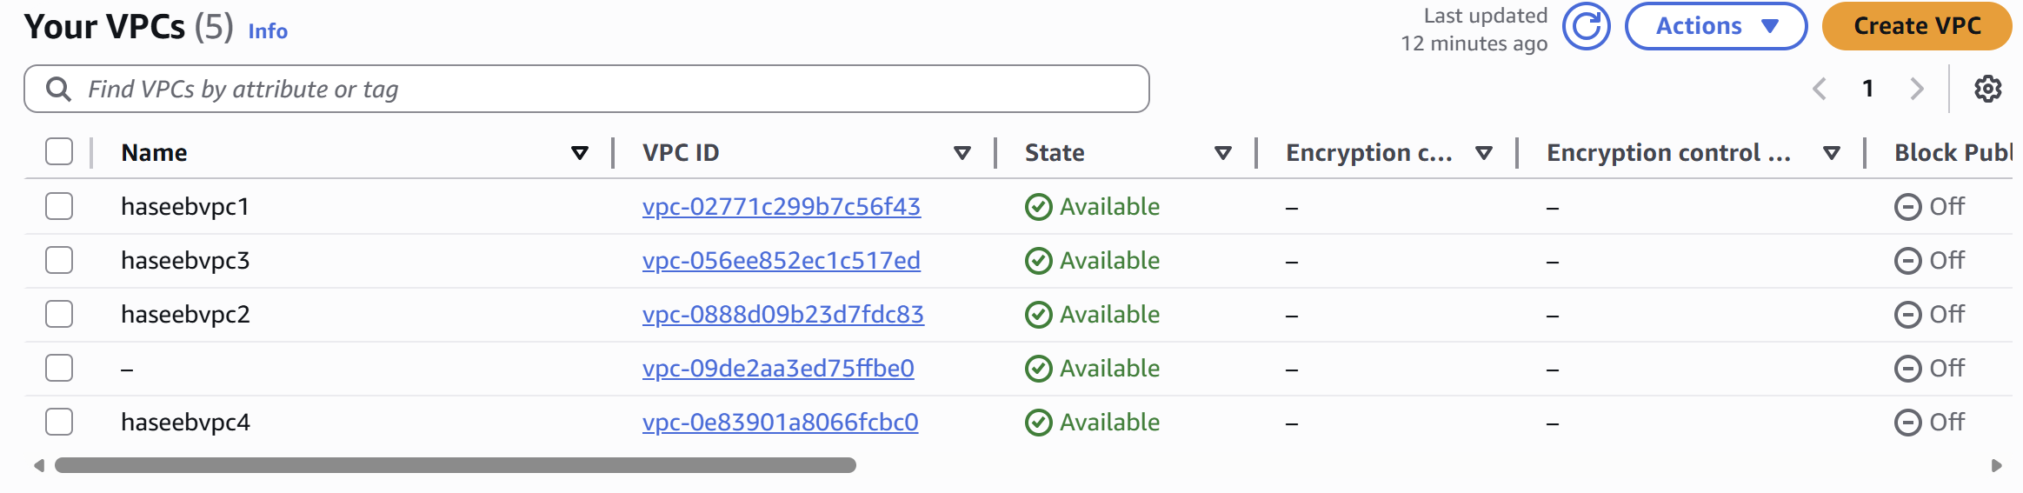
Then we created four subnets
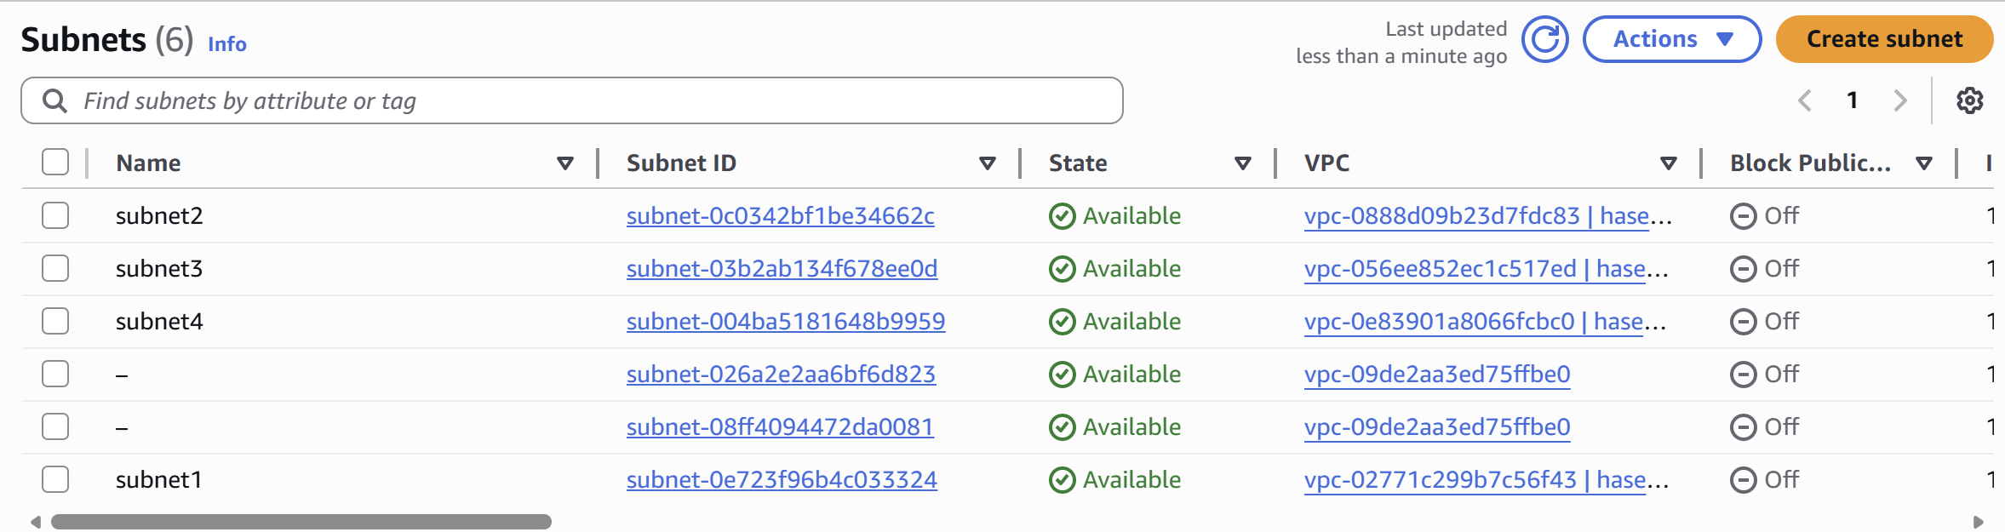
Then we created Transit Gateway
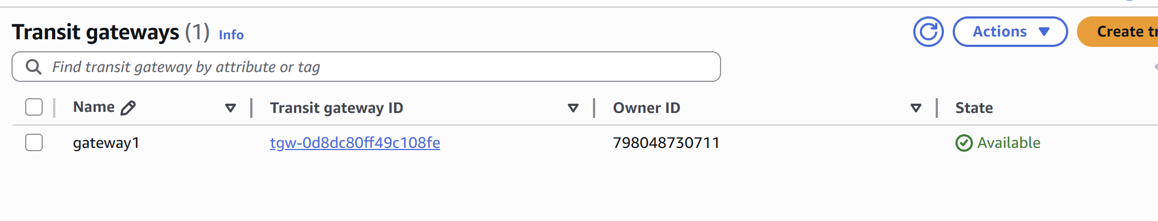
Then we created Transit gateway attachments
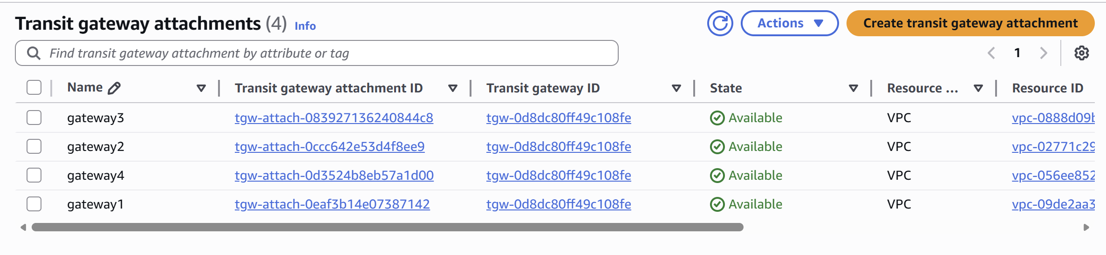
Then we created RT’s
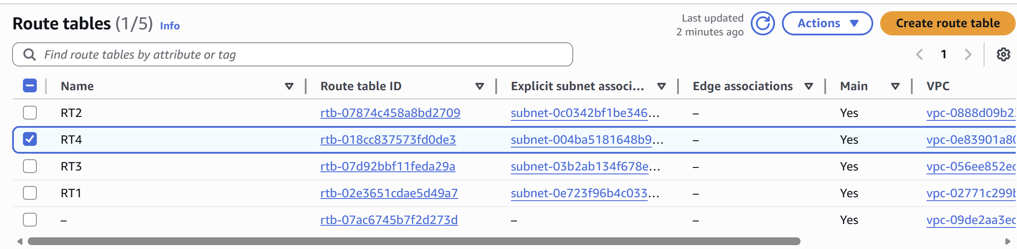
then we created IGW’s
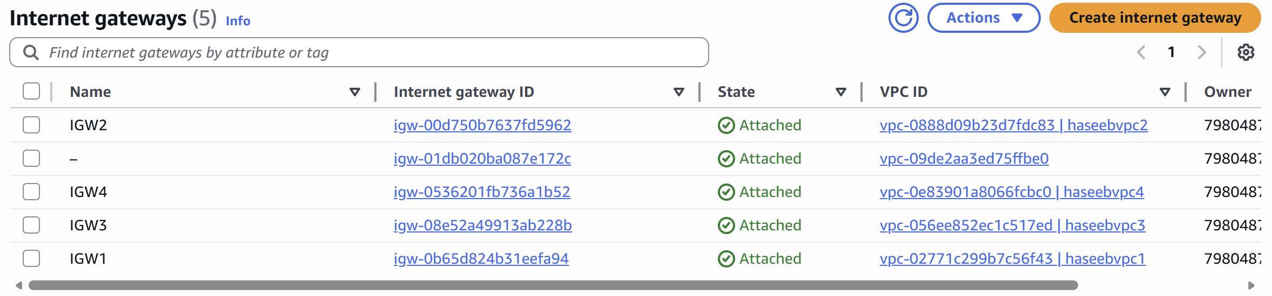
We have done subnet associations on four RT’s
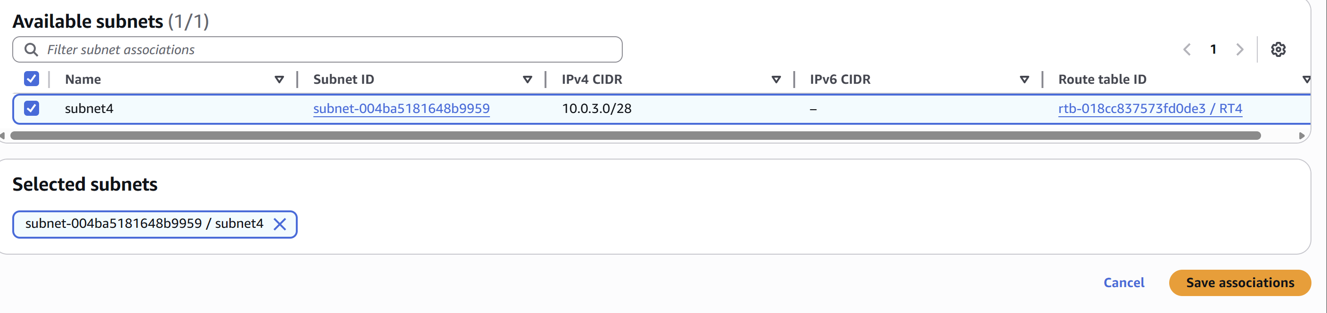
Then we created four EC2’s
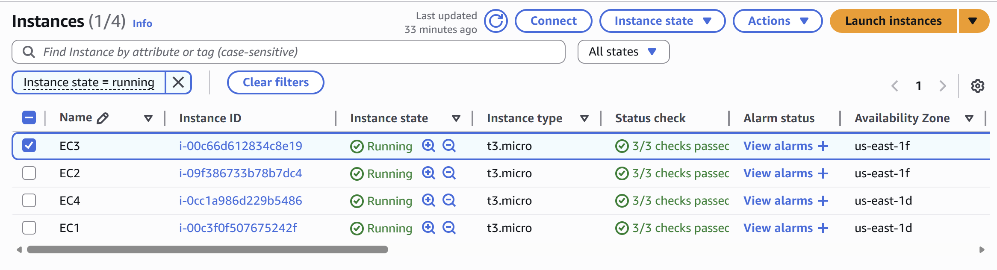
Go to security in each instances and edit the inbound rules and give all traffic routes. Then open the git bash and check for the connectivity for each private IP’s.
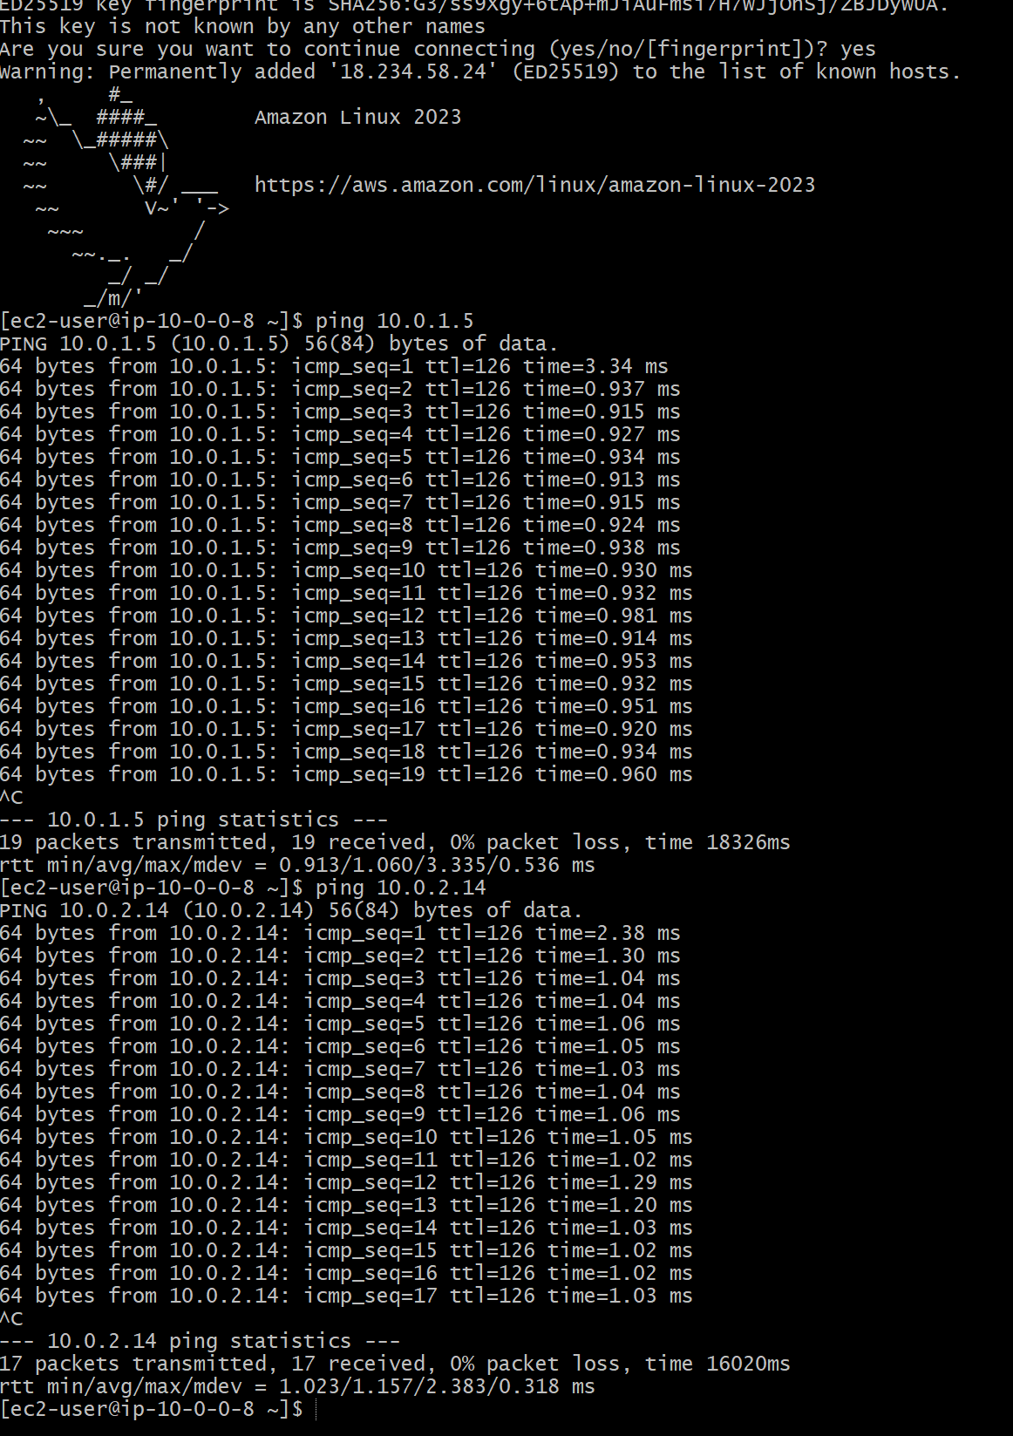

Endpoint
Created one vpc, under that we created 1 private and 1 public subnets
1)Create one VPC with one public subnet and one private subnet.
2) Provide internet access to only public subnet.
3) Launch one instance in public and one instance in private using the same
VPC.
4) Using bastion server try to connect to instance which is in private using
private IP.
5) And execute “aws s3 ls” this command will not work because of no
internet access.
6) Now to go to VPC Endpoint service.
How to Configure VPC end point:
1) First go to Vpc & under vpc you will find end points.
2) Give a name for the endpoint & select the service category as aws.
3) Then select the service as s3 and add any one of the service gateway.
4) And the select the VPC & choose the route table as private.
5) Then click on create endpoint and endpoint will be created and added to